Problem statement 1: Write a menu driven program to reverse a single linked list in O(N) time with a non-recursive function.
Objective: To develop a menu-driven C program that reverses a singly linked list using an iterative approach in linear time complexity O(N) without recursion.
Code:
#include <stdio.h>
#include <stdlib.h>
struct Node {
int data;
struct Node* next;
};
struct Node* insert(struct Node* head, int value) {
struct Node* newNode = (struct Node*)malloc(sizeof(struct Node));
newNode->data = value;
newNode->next = NULL;
if (head == NULL) {
return newNode;
}
struct Node* temp = head;
while (temp->next != NULL) {
temp = temp->next;
}
temp->next = newNode;
return head;
}
void display(struct Node* head) {
if (head == NULL) {
printf("List is empty\n");
return;
}
struct Node* temp = head;
while (temp != NULL) {
printf("%d -> ", temp->data);
temp = temp->next;
}
printf("NULL\n");
}
struct Node* reverse(struct Node* head) {
struct Node *prev = NULL, *curr = head, *next = NULL;
while (curr != NULL) {
next = curr->next;
curr->next = prev;
prev = curr;
curr = next;
}
return prev;
}
int main() {
struct Node* head = NULL;
int choice, value;
while (1) {
printf("\n--- MENU ---\n");
printf("1. Insert\n");
printf("2. Display\n");
printf("3. Reverse\n");
printf("4. Exit\n");
printf("Enter choice: ");
scanf("%d", &choice);
switch (choice) {
case 1:
printf("Enter value: ");
scanf("%d", &value);
head = insert(head, value);
break;
case 2:
display(head);
break;
case 3:
head = reverse(head);
printf("List reversed successfully.\n");
break;
case 4:
exit(0);
default:
printf("Invalid choice!\n");
}
}
return 0;
}

Output:
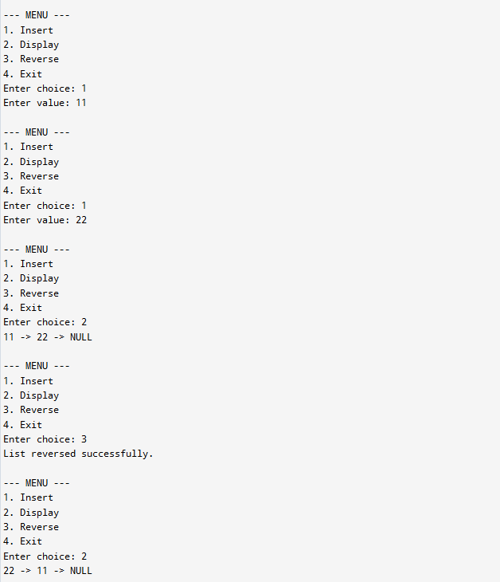

Problem statement 2: Write a menu driven program to delete duplicate name(if any) in the single Link list. The information field of each node should contain name and noll no of students.
Objective: To design a menu-driven C program that stores student records (name and roll number) in a singly linked list and removes duplicate entries based on student names.
Code:
#include <stdio.h>
#include <stdlib.h>
#include <string.h>
struct Node {
char name[50];
int roll;
struct Node* next;
};
struct Node* insert(struct Node* head, char name[], int roll) {
struct Node* newNode = (struct Node*)malloc(sizeof(struct Node));
strcpy(newNode->name, name);
newNode->roll = roll;
newNode->next = NULL;
if (head == NULL)
return newNode;
struct Node* temp = head;
while (temp->next != NULL)
temp = temp->next;
temp->next = newNode;
return head;
}
void display(struct Node* head) {
if (head == NULL) {
printf("List is empty\n");
return;
}
struct Node* temp = head;
while (temp != NULL) {
printf("Name: %s, Roll: %d -> ", temp->name, temp->roll);
temp = temp->next;
}
printf("NULL\n");
}
struct Node* deleteDuplicates(struct Node* head) {
struct Node *current, *temp, *prev;
for (current = head; current != NULL; current = current->next) {
prev = current;
temp = current->next;
while (temp != NULL) {
if (strcmp(current->name, temp->name) == 0) {
prev->next = temp->next;
free(temp);
temp = prev->next;
} else {
prev = temp;
temp = temp->next;
}
}
}
return head;
}
int main() {
struct Node* head = NULL;
int choice, roll;
char name[50];
while (1) {
printf("\n--- MENU ---\n");
printf("1. Insert\n");
printf("2. Display\n");
printf("3. Delete Duplicate Names\n");
printf("4. Exit\n");
printf("Enter choice: ");
scanf("%d", &choice);
switch (choice) {
case 1:
printf("Enter name: ");
scanf("%s", name);
printf("Enter roll no: ");
scanf("%d", &roll);
head = insert(head, name, roll);
break;
case 2:
display(head);
break;
case 3:
head = deleteDuplicates(head);
printf("Duplicate names deleted.\n");
break;
case 4:
exit(0);
default:
printf("Invalid choice!\n");
}
}
return 0;
}
Output:
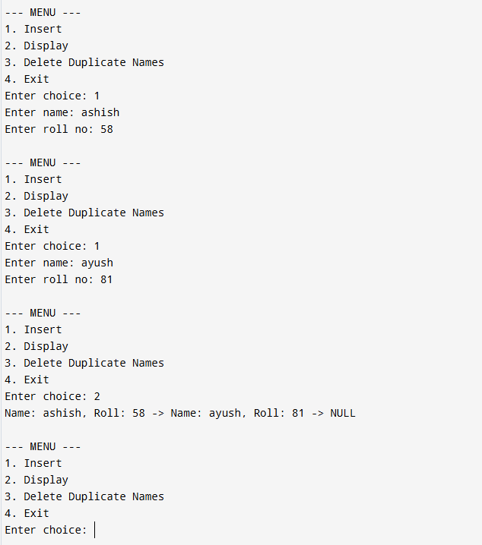

Problem statement 3: Write a C program to create a single linked list, then find whether there exist any two nodes in the linked list whose multiplication is less than the target value.
Example:
Input: Linked-List = 12->15->3->4->6, Target = 20
Output: Yes
Objective: To create a singly linked list and check whether there exists at least one pair of nodes whose multiplication is less than a given target value.
Code:
#include <stdio.h>
#include <stdlib.h>
struct Node {
int data;
struct Node* next;
};
struct Node* insert(struct Node* head, int value) {
struct Node* newNode = (struct Node*)malloc(sizeof(struct Node));
newNode->data = value;
newNode->next = NULL;
if (head == NULL)
return newNode;
struct Node* temp = head;
while (temp->next != NULL)
temp = temp->next;
temp->next = newNode;
return head;
}
void display(struct Node* head) {
struct Node* temp = head;
while (temp != NULL) {
printf("%d -> ", temp->data);
temp = temp->next;
}
printf("NULL\n");
}
int checkPair(struct Node* head, int target) {
struct Node *p, *q;
for (p = head; p != NULL; p = p->next) {
for (q = p->next; q != NULL; q = q->next) {
if ((p->data * q->data) < target) {
printf("Pair found: (%d, %d)\n", p->data, q->data);
return 1; // Yes
}
}
}
return 0; // No
}
int main() {
struct Node* head = NULL;
int choice, value, target;
while (1) {
printf("\n--- MENU ---\n");
printf("1. Insert\n");
printf("2. Display\n");
printf("3. Check Pair Product < Target\n");
printf("4. Exit\n");
printf("Enter choice: ");
scanf("%d", &choice);
switch (choice) {
case 1:
printf("Enter value: ");
scanf("%d", &value);
head = insert(head, value);
break;
case 2:
display(head);
break;
case 3:
printf("Enter target value: ");
scanf("%d", &target);
if (checkPair(head, target))
printf("Yes\n");
else
printf("No\n");
break;
case 4:
exit(0);
default:
printf("Invalid choice!\n");
}
}
return 0;
}

Output:
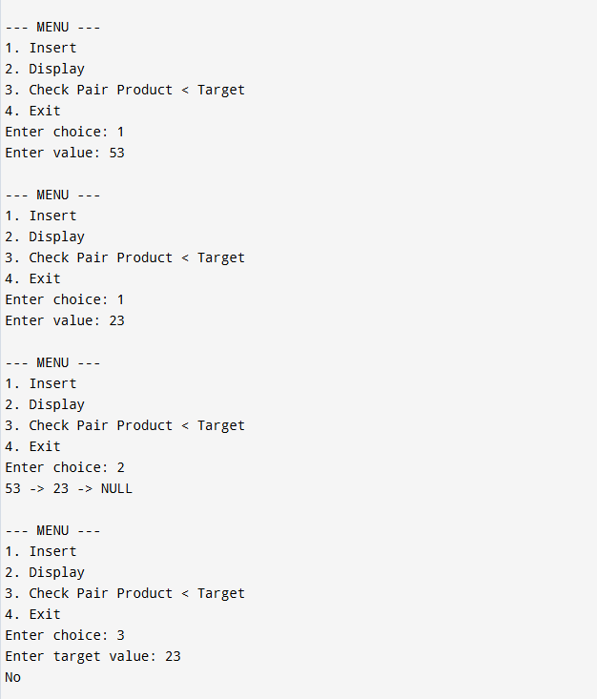
Problem statement 4: W.A.P. to create a binary search tree and perform the following operations:
1) Find a node with second highest data.
2) Delete a node from the tree.
3) Count total number of nodes having common parent.
4) Find the height of a binary search tree
5) Count total numbers of nodes from left hand side of the root node
Objective:
To implement a Binary Search Tree (BST) in C and perform various operations such as:
- Finding the second largest element
- Deleting a node
- Counting nodes with a common parent
- Calculating tree height
- Counting nodes in the left subtree of the root
Code:
#include <stdio.h>
#include <stdlib.h>
struct Node {
int data;
struct Node *left, *right;
};
// Create new node
struct Node* createNode(int data) {
struct Node* newNode = (struct Node*)malloc(sizeof(struct Node));
newNode->data = data;
newNode->left = newNode->right = NULL;
return newNode;
}
// Insert in BST
struct Node* insert(struct Node* root, int data) {
if (root == NULL)
return createNode(data);
if (data < root->data)
root->left = insert(root->left, data);
else
root->right = insert(root->right, data);
return root;
}
// Inorder traversal
void inorder(struct Node* root) {
if (root != NULL) {
inorder(root->left);
printf("%d ", root->data);
inorder(root->right);
}
}
// 1) Find second highest node
int findSecondMax(struct Node* root) {
struct Node *parent = NULL, *current = root;
if (root == NULL || (root->left == NULL && root->right == NULL)) {
printf("Not enough nodes\n");
return -1;
}
// Move to rightmost node
while (current->right != NULL) {
parent = current;
current = current->right;
}
// Case 1: max node has left subtree
if (current->left != NULL) {
current = current->left;
while (current->right != NULL)
current = current->right;
return current->data;
}
// Case 2: parent is second max
return parent->data;
}
// Find minimum (used in delete)
struct Node* findMin(struct Node* root) {
while (root->left != NULL)
root = root->left;
return root;
}
// 2) Delete a node
struct Node* deleteNode(struct Node* root, int key) {
if (root == NULL) return NULL;
if (key < root->data)
root->left = deleteNode(root->left, key);
else if (key > root->data)
root->right = deleteNode(root->right, key);
else {
// Node found
if (root->left == NULL) {
struct Node* temp = root->right;
free(root);
return temp;
}
else if (root->right == NULL) {
struct Node* temp = root->left;
free(root);
return temp;
}
// Two children
struct Node* temp = findMin(root->right);
root->data = temp->data;
root->right = deleteNode(root->right, temp->data);
}
return root;
}
// 3) Count nodes having common parent (siblings)
int countSiblings(struct Node* root) {
if (root == NULL)
return 0;
int count = 0;
if (root->left != NULL && root->right != NULL)
count += 2; // both are siblings
return count + countSiblings(root->left) + countSiblings(root->right);
}
// 4) Height of BST
int height(struct Node* root) {
if (root == NULL)
return -1;
int leftH = height(root->left);
int rightH = height(root->right);
return (leftH > rightH ? leftH : rightH) + 1;
}
// 5) Count nodes in left subtree of root
int countNodes(struct Node* root) {
if (root == NULL)
return 0;
return 1 + countNodes(root->left) + countNodes(root->right);
}
int countLeftSubtree(struct Node* root) {
if (root == NULL || root->left == NULL)
return 0;
return countNodes(root->left);
}
// Main menu
int main() {
struct Node* root = NULL;
int choice, value;
while (1) {
printf("\n--- MENU ---\n");
printf("1. Insert\n");
printf("2. Display (Inorder)\n");
printf("3. Find Second Highest\n");
printf("4. Delete Node\n");
printf("5. Count Nodes with Common Parent\n");
printf("6. Find Height\n");
printf("7. Count Left Subtree Nodes\n");
printf("8. Exit\n");
printf("Enter choice: ");
scanf("%d", &choice);
switch (choice) {
case 1:
printf("Enter value: ");
scanf("%d", &value);
root = insert(root, value);
break;
case 2:
printf("Inorder: ");
inorder(root);
printf("\n");
break;
case 3:
printf("Second Highest: %d\n", findSecondMax(root));
break;
case 4:
printf("Enter value to delete: ");
scanf("%d", &value);
root = deleteNode(root, value);
break;
case 5:
printf("Nodes with common parent: %d\n", countSiblings(root));
break;
case 6:
printf("Height of tree: %d\n", height(root));
break;
case 7:
printf("Nodes in left subtree: %d\n", countLeftSubtree(root));
break;
case 8:
exit(0);
default:
printf("Invalid choice!\n");
}
}
}
Output:
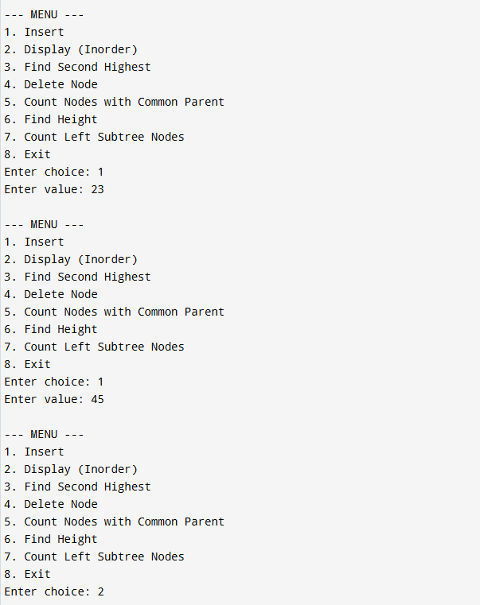

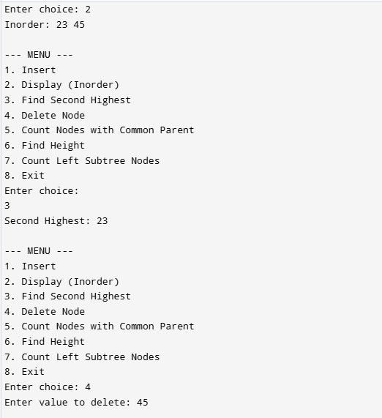
Problem statement 5: Write a C program to implement time sharing environment using circular linked list to allocate time slots of 10ns for N given processes, and then print which process will be completed in how much time.
Objective: To simulate a time-sharing system using a circular linked list where processes are allocated equal time slices (10 ns) and compute completion times.
Code:
#include <stdio.h>
#include <stdlib.h>
#define TIME_QUANTUM 10
// Process node
struct Process {
int pid;
int burst;
int remaining;
int completionTime;
struct Process* next;
};
// Insert process into circular linked list
struct Process* insert(struct Process* tail, int pid, int burst) {
struct Process* newNode = (struct Process*)malloc(sizeof(struct Process));
newNode->pid = pid;
newNode->burst = burst;
newNode->remaining = burst;
newNode->completionTime = 0;
if (tail == NULL) {
newNode->next = newNode;
return newNode;
}
newNode->next = tail->next;
tail->next = newNode;
return newNode;
}
// Display processes
void display(struct Process* tail) {
if (tail == NULL) {
printf("No processes\n");
return;
}
struct Process* temp = tail->next;
do {
printf("P%d (Burst=%d) -> ", temp->pid, temp->burst);
temp = temp->next;
} while (temp != tail->next);
printf("(Back to start)\n");
}
// Round Robin Scheduling
void roundRobin(struct Process* tail) {
if (tail == NULL) {
printf("No processes to schedule\n");
return;
}
int time = 0;
int done;
struct Process* temp;
do {
done = 1;
temp = tail->next;
do {
if (temp->remaining > 0) {
done = 0;
if (temp->remaining > TIME_QUANTUM) {
time += TIME_QUANTUM;
temp->remaining -= TIME_QUANTUM;
} else {
time += temp->remaining;
temp->remaining = 0;
temp->completionTime = time;
}
}
temp = temp->next;
} while (temp != tail->next);
} while (!done);
// Print result
printf("\nProcess Completion Times:\n");
temp = tail->next;
do {
printf("P%d completed at %d ns\n", temp->pid, temp->completionTime);
temp = temp->next;
} while (temp != tail->next);
}
// Main menu
int main() {
struct Process* tail = NULL;
int choice, pid = 1, burst;
while (1) {
printf("\n--- MENU ---\n");
printf("1. Add Process\n");
printf("2. Display Processes\n");
printf("3. Run Time Sharing (Round Robin)\n");
printf("4. Exit\n");
printf("Enter choice: ");
scanf("%d", &choice);
switch (choice) {
case 1:
printf("Enter burst time: ");
scanf("%d", &burst);
tail = insert(tail, pid++, burst);
break;
case 2:
display(tail);
break;
case 3:
roundRobin(tail);
break;
case 4:
exit(0);
default:
printf("Invalid choice!\n");
}
}
}

Output:
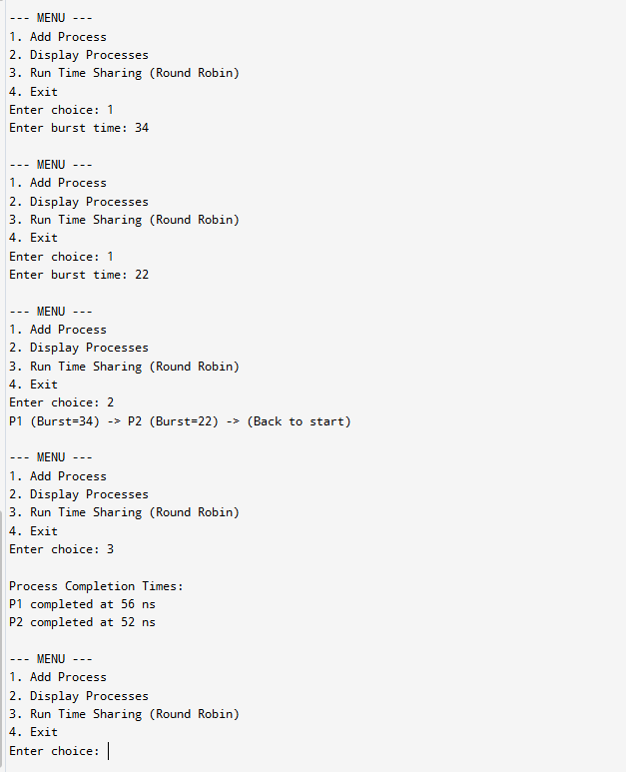

Problem statement 6: Write a C program to store the details of a weighted graph (Using Adjacency list).
Objective: To represent a weighted graph efficiently using an adjacency list and store vertex-edge relationships with weights.
Code:
#include <stdio.h>
#include <stdlib.h>
// Node for adjacency list
struct Node {
int dest;
int weight;
struct Node* next;
};
// Graph structure
struct Graph {
int V;
struct Node** adjList;
};
// Create new node
struct Node* createNode(int dest, int weight) {
struct Node* newNode = (struct Node*)malloc(sizeof(struct Node));
newNode->dest = dest;
newNode->weight = weight;
newNode->next = NULL;
return newNode;
}
// Create graph
struct Graph* createGraph(int V) {
struct Graph* graph = (struct Graph*)malloc(sizeof(struct Graph));
graph->V = V
graph->adjList = (struct Node**)malloc(V * sizeof(struct Node*));
for (int i = 0; i < V; i++)
graph->adjList[i] = NULL;
return graph;

// Add edge (directed)
void addEdge(struct Graph* graph, int src, int dest, int weight) {
struct Node* newNode = createNode(dest, weight);
newNode->next = graph->adjList[src];
graph->adjList[src] = newNode;
}
// Display graph
void displayGraph(struct Graph* graph) {
for (int i = 0; i < graph->V; i++) {
struct Node* temp = graph->adjList[i];
printf("Vertex %d: ", i);
while (temp != NULL) {
printf("-> (%d, w=%d) ", temp->dest, temp->weight);
temp = temp->next;
}
printf("\n");
}
}
// Main menu
int main() {
struct Graph* graph = NULL;
int choice, V, src, dest, weight;
while (1) {
printf("\n--- MENU ---\n");
printf("1. Create Graph\n");
printf("2. Add Edge\n");
printf("3. Display Graph\n");
printf("4. Exit\n");
printf("Enter choice: ");
scanf("%d", &choice);
switch (choice) {
case 1:
printf("Enter number of vertices: ");
scanf("%d", &V);
graph = createGraph(V);
printf("Graph created with %d vertices\n", V);
break;
case 2:
if (graph == NULL) {
printf("Create graph first!\n");
break;
}
printf("Enter source, destination and weight: ");
scanf("%d %d %d", &src, &dest, &weight);
if (src >= graph->V || dest >= graph->V) {
printf("Invalid vertices!\n");
} else {
addEdge(graph, src, dest, weight);
}
break;
case 3:
if (graph == NULL) {
printf("Graph not created yet!\n");
} else {
displayGraph(graph);
}
break;
case 4:
exit(0);
default:
printf("Invalid choice!\n");
}
}
return 0;
}

Output:
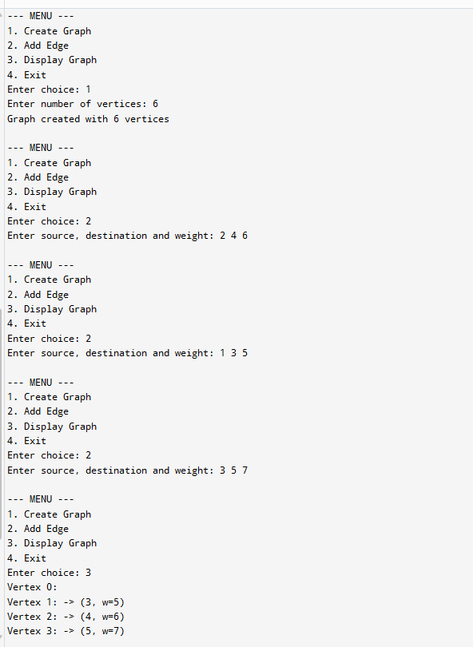

Problem statement 7: Write a C program to implement DFS, using linked list.
Objective: To implement Depth First Search (DFS) traversal of a graph using linked list representation.
Code:
#include <stdio.h>
#include <stdlib.h>
// Node for adjacency list
struct Node {
int vertex;
struct Node* next;
};
// Graph structure
struct Graph {
int V;
struct Node** adjList;
};
// Create node
struct Node* createNode(int v) {
struct Node* newNode = (struct Node*)malloc(sizeof(struct Node));
newNode->vertex = v;
newNode->next = NULL;
return newNode;
}
// Create graph
struct Graph* createGraph(int V) {
struct Graph* graph = (struct Graph*)malloc(sizeof(struct Graph));
graph->V = V;
graph->adjList = (struct Node**)malloc(V * sizeof(struct Node*));
for (int i = 0; i < V; i++)
graph->adjList[i] = NULL;
return graph;
}
// Add edge (undirected)
void addEdge(struct Graph* graph, int src, int dest) {
struct Node* newNode = createNode(dest);
newNode->next = graph->adjList[src];
graph->adjList[src] = newNode;
// For undirected graph
newNode = createNode(src);
newNode->next = graph->adjList[dest];
graph->adjList[dest] = newNode;
}
// Display graph
void displayGraph(struct Graph* graph) {
for (int i = 0; i < graph->V; i++) {
struct Node* temp = graph->adjList[i];
printf("Vertex %d: ", i);
while (temp != NULL) {
printf("%d -> ", temp->vertex);
temp = temp->next;
}
printf("NULL\n");
}
}
// DFS recursive function
void DFSUtil(struct Graph* graph, int v, int visited[]) {
visited[v] = 1;
printf("%d ", v);
struct Node* temp = graph->adjList[v];
while (temp != NULL) {
if (!visited[temp->vertex])
DFSUtil(graph, temp->vertex, visited);
temp = temp->next;
}
}
// DFS driver
void DFS(struct Graph* graph, int start) {
int* visited = (int*)calloc(graph->V, sizeof(int));
printf("DFS Traversal: ");
DFSUtil(graph, start, visited);
printf("\n");
free(visited);
}
// Main menu
int main() {
struct Graph* graph = NULL;
int choice, V, src, dest, start;
while (1) {
printf("\n--- MENU ---\n");
printf("1. Create Graph\n");
printf("2. Add Edge\n");
printf("3. Display Graph\n");
printf("4. DFS Traversal\n");
printf("5. Exit\n");
printf("Enter choice: ");
scanf("%d", &choice);
switch (choice) {
case 1:
printf("Enter number of vertices: ");
scanf("%d", &V);
graph = createGraph(V);
printf("Graph created\n");
break;
case 2:
if (graph == NULL) {
printf("Create graph first!\n");
break;
}
printf("Enter source and destination: ");
scanf("%d %d", &src, &dest);
if (src >= graph->V || dest >= graph->V)
printf("Invalid vertices!\n");
else
addEdge(graph, src, dest);
break;
case 3:
if (graph == NULL)
printf("Graph not created!\n");
else
displayGraph(graph);
break;
case 4:
if (graph == NULL) {
printf("Create graph first!\n");
break;
}
printf("Enter starting vertex: ");
scanf("%d", &start);
if (start >= graph->V)
printf("Invalid start vertex!\n");
else
DFS(graph, start);
break;
case 5:
exit(0);
default:
printf("Invalid choice!\n");
}
}
}

Output:
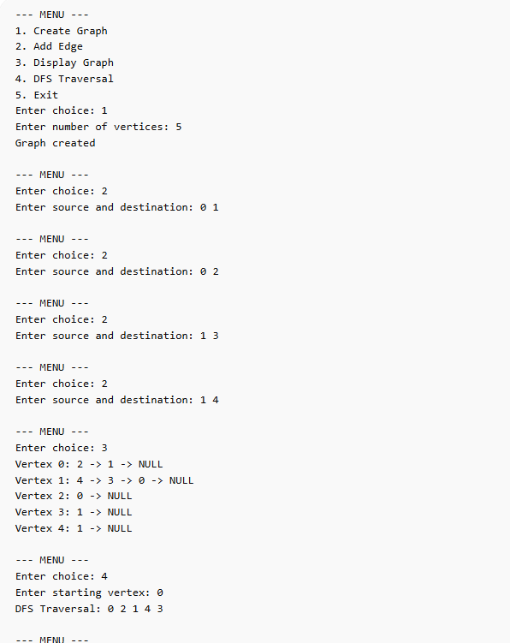

Problem statement 8: Write a C program to implement DFS using an adjacency list.
Objective: To perform DFS traversal on a graph represented through an adjacency list for efficient exploration.
Code:
#include <stdio.h>
#include <stdlib.h>
// Node structure for adjacency list
struct Node {
int vertex;
struct Node* next;
};
// Graph structure
struct Graph {
int V;
struct Node** adjList;
};
// Create a new node
struct Node* createNode(int v) {
struct Node* newNode = (struct Node*)malloc(sizeof(struct Node));
newNode->vertex = v;
newNode->next = NULL;
return newNode;
}
// Create graph
struct Graph* createGraph(int V) {
struct Graph* graph = (struct Graph*)malloc(sizeof(struct Graph));
graph->V = V;
graph->adjList = (struct Node**)malloc(V * sizeof(struct Node*));
for (int i = 0; i < V; i++)
graph->adjList[i] = NULL;
return graph;
}
// Add edge (undirected)
void addEdge(struct Graph* graph, int src, int dest) {
struct Node* newNode = createNode(dest);
newNode->next = graph->adjList[src];
graph->adjList[src] = newNode;
newNode = createNode(src);
newNode->next = graph->adjList[dest];
graph->adjList[dest] = newNode;
}
// Display graph
void display(struct Graph* graph) {
for (int i = 0; i < graph->V; i++) {
struct Node* temp = graph->adjList[i];
printf("Vertex %d: ", i);
while (temp) {
printf("%d -> ", temp->vertex);
temp = temp->next;
}
printf("NULL\n");
}
}
// DFS utility
void DFSUtil(struct Graph* graph, int v, int visited[]) {
visited[v] = 1;
printf("%d ", v);
struct Node* temp = graph->adjList[v];
while (temp != NULL) {
if (!visited[temp->vertex]) {
DFSUtil(graph, temp->vertex, visited);
}
temp = temp->next;
}
}
// DFS function
void DFS(struct Graph* graph, int start) {
int* visited = (int*)calloc(graph->V, sizeof(int));
printf("DFS Traversal: ");
DFSUtil(graph, start, visited);
printf("\n");
free(visited);
}
// Main function
int main() {
struct Graph* graph = NULL;
int choice, V, src, dest, start;
while (1) {
printf("\n--- MENU ---\n");
printf("1. Create Graph\n");
printf("2. Add Edge\n");
printf("3. Display Graph\n");
printf("4. Perform DFS\n");
printf("5. Exit\n");
printf("Enter choice: ");
scanf("%d", &choice);
switch (choice) {
case 1:
printf("Enter number of vertices: ");
scanf("%d", &V);
graph = createGraph(V);
printf("Graph created\n");
break;
case 2:
if (!graph) {
printf("Create graph first!\n");
break;
}
printf("Enter source and destination: ");
scanf("%d %d", &src, &dest);
if (src >= graph->V || dest >= graph->V)
printf("Invalid vertices!\n");
else
addEdge(graph, src, dest);
break;
case 3:
if (!graph)
printf("Graph not created!\n");
else
display(graph);
break;
case 4:
if (!graph) {
printf("Create graph first!\n");
break;
}
printf("Enter starting vertex: ");
scanf("%d", &start);
if (start >= graph->V)
printf("Invalid vertex!\n");
else
DFS(graph, start);
break;
case 5:
exit(0);
default:
printf("Invalid choice!\n");
}
}
}

Output:
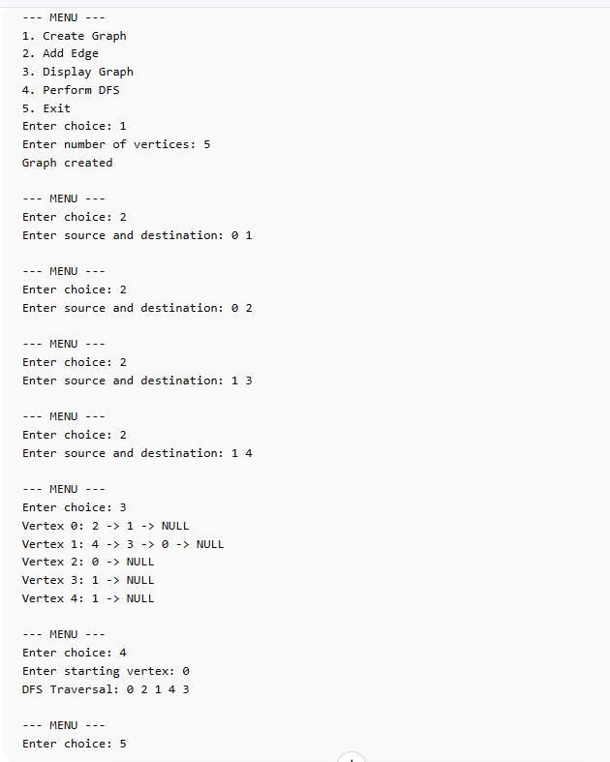

Problem statement 9: Write a C program to create a heap and then perform the following operations:
i) Heapify ii) Delete a node from the heap
Objective: To create a heap data structure and perform key operations such as heap construction (heapify) and deletion of nodes.
Code:
#include <stdio.h>
#include <stdlib.h>
// Swap function
void swap(int *a, int *b) {
int temp = *a;
*a = *b;
*b = temp;
}
// Heapify (Max Heap)
void heapify(int arr[], int n, int i) {
int largest = i;
int left = 2*i + 1;
int right = 2*i + 2;
if (left < n && arr[left] > arr[largest])
largest = left;
if (right < n && arr[right] > arr[largest])
largest = right;
if (largest != i) {
swap(&arr[i], &arr[largest]);
heapify(arr, n, largest);
}
}
// Build heap
void buildHeap(int arr[], int n) {
for (int i = n/2 - 1; i >= 0; i--)
heapify(arr, n, i);
}
// Delete root (max element)
int deleteMax(int arr[], int *n) {
if (*n <= 0) {
printf("Heap is empty\n");
return -1;
}
int root = arr[0];
arr[0] = arr[*n - 1];
(*n)--;
heapify(arr, *n, 0);
return root;
}
// Display heap
void display(int arr[], int n) {
if (n == 0) {
printf("Heap is empty\n");
return;
}
for (int i = 0; i < n; i++)
printf("%d ", arr[i]);
printf("\n");
}
// Main function
int main() {
int *heap = NULL;
int n = 0, capacity, choice, value;
while (1) {
printf("\n--- MENU ---\n");
printf("1. Create Heap\n");
printf("2. Heapify\n");
printf("3. Delete Max\n");
printf("4. Display\n");
printf("5. Exit\n");
printf("Enter choice: ");
scanf("%d", &choice);
switch (choice) {
case 1:
printf("Enter number of elements: ");
scanf("%d", &n);
heap = (int*)malloc(n * sizeof(int));
printf("Enter elements:\n");
for (int i = 0; i < n; i++)
scanf("%d", &heap[i]);
break;
case 2:
if (heap == NULL) {
printf("Create heap first!\n");
break;
}
buildHeap(heap, n);
printf("Heap created using heapify.\n");
break;
case 3:
if (heap == NULL || n == 0) {
printf("Heap is empty!\n");
break;
}
value = deleteMax(heap, &n);
if (value != -1)
printf("Deleted element: %d\n", value);
break;
case 4:
display(heap, n);
break;
case 5:
free(heap);
exit(0);
default:
printf("Invalid choice!\n");
}
}
}

Output:
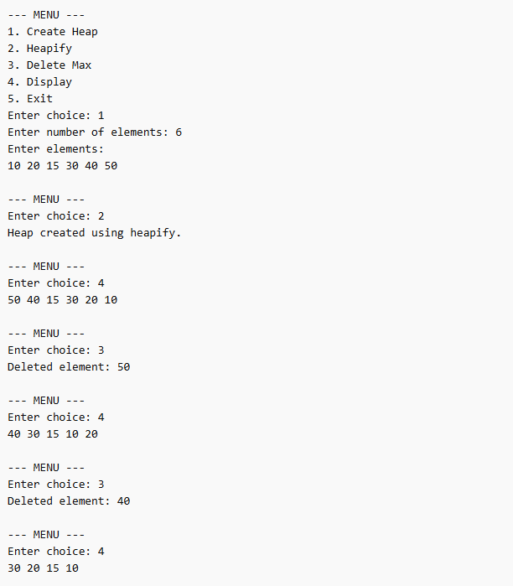

Problem statement 10: Write a C program to implement Kruskal’s algorithm using a min-heap.
Objective: To implement Kruskal’s algorithm for finding the Minimum Spanning Tree (MST) using a min-heap to efficiently select minimum weight edges.
Code:
#include <stdio.h>
#include <stdlib.h>
// Edge structure
struct Edge {
int src, dest, weight;
};
// Min Heap structure
struct MinHeap {
int size;
int capacity;
struct Edge* arr;
};
// Create heap
struct MinHeap* createHeap(int capacity) {
struct MinHeap* heap = (struct MinHeap*)malloc(sizeof(struct MinHeap));
heap->size = 0;
heap->capacity = capacity;
heap->arr = (struct Edge*)malloc(capacity * sizeof(struct Edge));
return heap;
}
// Swap edges
void swap(struct Edge* a, struct Edge* b) {
struct Edge temp = *a;
*a = *b;
*b = temp;
}
// Heapify
void heapify(struct MinHeap* heap, int i) {
int smallest = i;
int left = 2*i + 1;
int right = 2*i + 2;
if (left < heap->size && heap->arr[left].weight < heap->arr[smallest].weight)
smallest = left;
if (right < heap->size && heap->arr[right].weight < heap->arr[smallest].weight)
smallest = right;
if (smallest != i) {
swap(&heap->arr[i], &heap->arr[smallest]);
heapify(heap, smallest);
}
}
// Insert into heap
void insertHeap(struct MinHeap* heap, struct Edge e) {
int i = heap->size++;
heap->arr[i] = e;

while (i != 0 && heap->arr[(i-1)/2].weight > heap->arr[i].weight) {
swap(&heap->arr[i], &heap->arr[(i-1)/2]);
i = (i-1)/2;
}
}
// Extract min
struct Edge extractMin(struct MinHeap* heap) {
struct Edge root = heap->arr[0];
heap->arr[0] = heap->arr[--heap->size];
heapify(heap, 0);
return root;
}
// Find with path compression
int find(int parent[], int i) {
if (parent[i] != i)
parent[i] = find(parent, parent[i]);
return parent[i];
}
// Union
void unionSet(int parent[], int rank[], int x, int y) {
int xroot = find(parent, x);
int yroot = find(parent, y);
if (rank[xroot] < rank[yroot])
parent[xroot] = yroot;
else if (rank[xroot] > rank[yroot])
parent[yroot] = xroot;
else {
parent[yroot] = xroot;
rank[xroot]++;
}
}
// Kruskal Algorithm
void kruskal(struct MinHeap* heap, int V) {
struct Edge result[V];
int e = 0;
int* parent = (int*)malloc(V * sizeof(int));
int* rank = (int*)calloc(V, sizeof(int));
for (int i = 0; i < V; i++)
parent[i] = i;
while (e < V - 1 && heap->size > 0) {
struct Edge next = extractMin(heap);
int x = find(parent, next.src);
int y = find(parent, next.dest);
if (x != y) {
result[e++] = next;
unionSet(parent, rank, x, y);
}
}
printf("\nEdges in MST:\n");
int total = 0;
for (int i = 0; i < e; i++) {
printf("%d -- %d == %d\n", result[i].src, result[i].dest, result[i].weight);
total += result[i].weight;
}
printf("Total cost: %d\n", total);
free(parent);
free(rank);
}
// Main menu
int main() {
int choice, V, E, src, dest, weight;
struct MinHeap* heap = NULL;
while (1) {
printf("\n--- MENU ---\n");
printf("1. Create Graph (Edges)\n");
printf("2. Add Edge\n");
printf("3. Run Kruskal\n");
printf("4. Exit\n");
printf("Enter choice: ");
scanf("%d", &choice);
switch (choice) {
case 1:
printf("Enter number of vertices and edges: ");
scanf("%d %d", &V, &E);
heap = createHeap(E);
printf("Graph initialized\n");
break;
case 2:
if (!heap) {
printf("Create graph first!\n");
break;
}
printf("Enter src dest weight: ");
scanf("%d %d %d", &src, &dest, &weight);
struct Edge e = {src, dest, weight};
insertHeap(heap, e);
break;
case 3:
if (!heap) {
printf("Create graph first!\n");
break;
}
kruskal(heap, V);
break;
case 4:
free(heap->arr);
free(heap);
exit(0);
default:
printf("Invalid choice!\n");
}
}
}

Output:
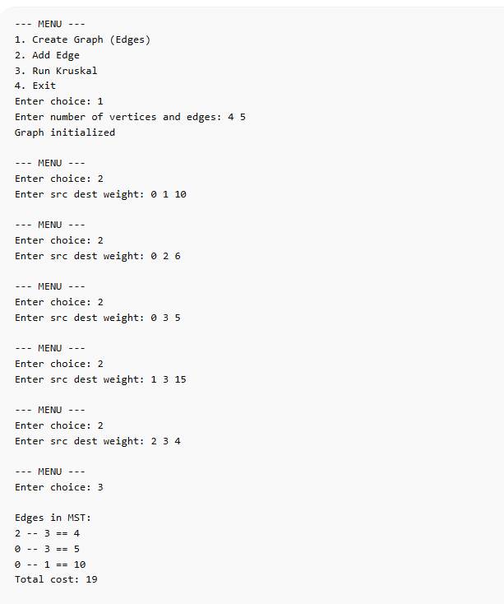

Problem statement 11: Write a C program to implement Dijkstra's algorithm.
Objective: To compute the shortest path from a source node to all other nodes in a graph using Dijkstra’s algorithm.
Code:
#include <stdio.h>
#include <stdlib.h>
#include <limits.h>
// Create graph (adjacency matrix)
int** createGraph(int V) {
int** graph = (int**)malloc(V * sizeof(int*));
for (int i = 0; i < V; i++) {
graph[i] = (int*)malloc(V * sizeof(int));
for (int j = 0; j < V; j++)
graph[i][j] = 0;
}
return graph;
}
// Add edge
void addEdge(int** graph, int src, int dest, int weight, int V) {
if (src < V && dest < V) {
graph[src][dest] = weight;
graph[dest][src] = weight; // undirected
}
}
// Display graph
void display(int** graph, int V) {
printf("\nAdjacency Matrix:\n");
for (int i = 0; i < V; i++) {
for (int j = 0; j < V; j++)
printf("%d ", graph[i][j]);
printf("\n");
}
}
// Find vertex with minimum distance
int minDistance(int dist[], int visited[], int V) {
int min = INT_MAX, min_index = -1;
for (int i = 0; i < V; i++) {
if (!visited[i] && dist[i] <= min) {
min = dist[i];
min_index = i;
}
}
return min_index;
}
// Dijkstra algorithm
void dijkstra(int** graph, int V, int src) {
int* dist = (int*)malloc(V * sizeof(int));
int* visited = (int*)calloc(V, sizeof(int));
for (int i = 0; i < V; i++)
dist[i] = INT_MAX;
dist[src] = 0;
for (int count = 0; count < V - 1; count++) {
int u = minDistance(dist, visited, V);
visited[u] = 1;
for (int v = 0; v < V; v++) {
if (!visited[v] && graph[u][v] &&
dist[u] != INT_MAX &&
dist[u] + graph[u][v] < dist[v]) {
dist[v] = dist[u] + graph[u][v];
}
}
}
printf("\nShortest distances from source %d:\n", src);
for (int i = 0; i < V; i++)
printf("To %d = %d\n", i, dist[i]);
free(dist);
free(visited);
}
// Main menu
int main() {
int** graph = NULL;
int V = 0;
int choice, src, dest, weight, start;
while (1) {
printf("\n--- MENU ---\n");
printf("1. Create Graph\n");
printf("2. Add Edge\n");
printf("3. Display Graph\n");
printf("4. Run Dijkstra\n");
printf("5. Exit\n");
printf("Enter choice: ");
scanf("%d", &choice);
switch (choice) {
case 1:
printf("Enter number of vertices: ");
scanf("%d", &V);
graph = createGraph(V);
printf("Graph created\n");
break;
case 2:
if (!graph) {
printf("Create graph first!\n");
break;
}
printf("Enter source, destination, weight: ");
scanf("%d %d %d", &src, &dest, &weight);
addEdge(graph, src, dest, weight, V);
break;
case 3:
if (!graph)
printf("Graph not created!\n");
else
display(graph, V);
break;
case 4:
if (!graph) {
printf("Create graph first!\n");
break;
}
printf("Enter source vertex: ");
scanf("%d", &start);
if (start >= V)
printf("Invalid source!\n");
else
dijkstra(graph, V, start);
break;
case 5:
// Free memory
if (graph) {
for (int i = 0; i < V; i++)
free(graph[i]);
free(graph);
}
exit(0);
default:
printf("Invalid choice!\n");
}
}
}

Output:
